**KAMPALA PARENTS’ SCHOOL 2004**

**END OF YEAR EXAMINATION, 2018**

**P.1 ENGLISH**

**NAME: _______________________________ STREAM: __________ DATE: __________**

**1.** **Read and draw.**

|  |  |  |
| --- | --- | --- |
| box | Pot | bag |
|  |  |  |

**2. Name these pictures**

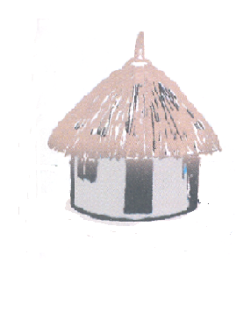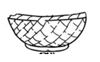

_________________ ___________________

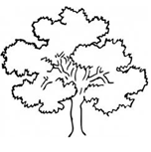

________________________

**3. Choose the correct word from the brackets.**

a. Sam has _____________ orange. (a, an)

b. She _____________ a new dress. (has, have)

c. The boy _________ crying. (are, is)

d. I have black __________hair, air)

e. A ______________ can fly. (bad, bird)

**- 2 -**

**4. What is this?**

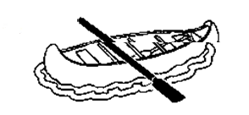

a. This is a **boat**

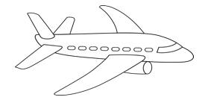

b. _________________________________________

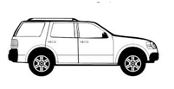

c. _________________________________________



d. __________________________________________

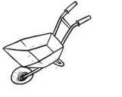

e. __________________________________________

( **train, wheelbarrow, an aeroplane, car)**

**5. Write the sentences correctly.**

a. girl is good a She .

_____________________________________________________________________

b. pot a is This .

_____________________________________________________________________

c. a book I have .

______________________________________________________________________

**6. Use the words in the brackets correctly.**

a. I am _________________ to school. (go)

b. They are ___________________ netball. (play)

c. The girls are ___________________ the classroom. (sweep)

**- 3 -**

d. The baby is ________________________. (cry)

e. He is ______________________ on a mat. (sit)

**7. Write a small word from a big word.**

a. teacher - tea b. chair - ___________________

c. train - ____________ d. pin - ______________

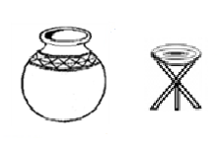**8. Use in, under, on, over, near.**

a. The stool is ______________ the pot.

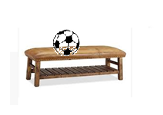

b. The ball is __________ the table.

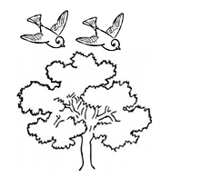

c. The birds are flying ___________ the tree.

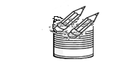

d. The pencils are ____________the tin.

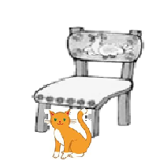

e. The cat is ______________ the chair.

**9. Write the number word.**

2 - ________________ 4 - ________________ 10 - __________________

**10. What are they doing?**

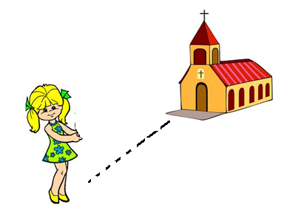

a.

She is_________________ to church.

**- 4 –**

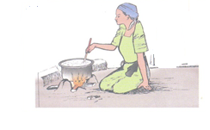

b.

Mummy is ____________________food.

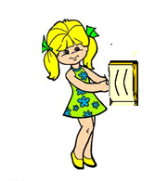

c. I am _____________________ a book.

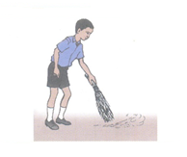

d. Peter is ______________________ the compound.

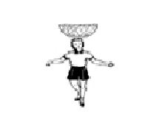

e.

The girl is ________________________ a basket.

(**sweeping, reading, carrying, running, cooking)**

**11 Fill in the correct word.**

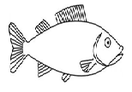

My mother cooks good food. She cooks _________________ and

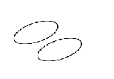

posho in the pot for lunch. She gives us ________________ and

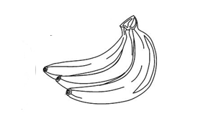

____________________ for breakfast.

**12. Write these words in plural form.**

a. glass - glasses

b. lorry - ________________

c. tin - ________________

d. leaf - ________________

e. bench - ________________

**- 5 -**

**13. Read this story.**

**Sarah**

Sarah has a brother. His name is Ben. They live with their grandmother.

Sarah is making a mat to sit on. Ben is making a ball to play with.

The grandmother is making a basket to carry things.

a. Who is making a ball?

_____________________________________________________________________

b. _______________ is Sarah's brother.

c. Draw these crafts.

|  |  |
| --- | --- |
| ball | basket |
|  |  |

***GOOD LUCK***